CSCI222 Assignment 1 Report

Team Number : G6

 | Student Number | Name | Email Address
1 | 5922756 | (Leader)  Tan Jia Yang | Tel:91251864  jytan070@mymail.sim.edu.sg
2 | 5920796 | Xu Ke | xuke4@yahoo.com
3 | 5841161 | Chiang Jun Yi | c.junyi93@gmail.com
4 | 5841252 | Lee Yi Ern Mark | leeyemark@gmail.com
5 | 5920668 | Stanley Teo | stanley.teo@mensa.org.sg
6 | 5987416 | Benjamin Lim Kay Ming | benvmon3@hotmail.com
7 | 5920164 | Lam How Wei | lamhowwei95@gmail.com

Table of Contents requirements

This SECOND page is to contain the heading "Contents" and an index built using the insert table of contents facility in Word

(insert the page and heading at this stage and then insert the table of contents when the rest of the document is complete).

Tip: To start off, you can research the Insert | Reference | Index and Tables (in Word 2003)

Project Overview

A brief overview of the project based on information in this assignment specification and details of the actual application.

This overview should not be created by simply cutting and pasting text supplied. It should be written by the members of the group and provide a retrospective view of the project on its completion.
g
It should be “complete” in the sense that it explains the project to an external assessor who has not seen any of the assignment details.

Examples of relevant information includes:

- "Vision"

- What is the general vision of the system's key features, core project's requirements and main constraints

A Warehouse Management Tool can be used by companies to streamline processes and to keep records secure. System has a few key features, namely encryption of data, provide alerts when stock level has reached previously set threshold.
Project requirements:
Main constraints:

- Initial Use-Case Model

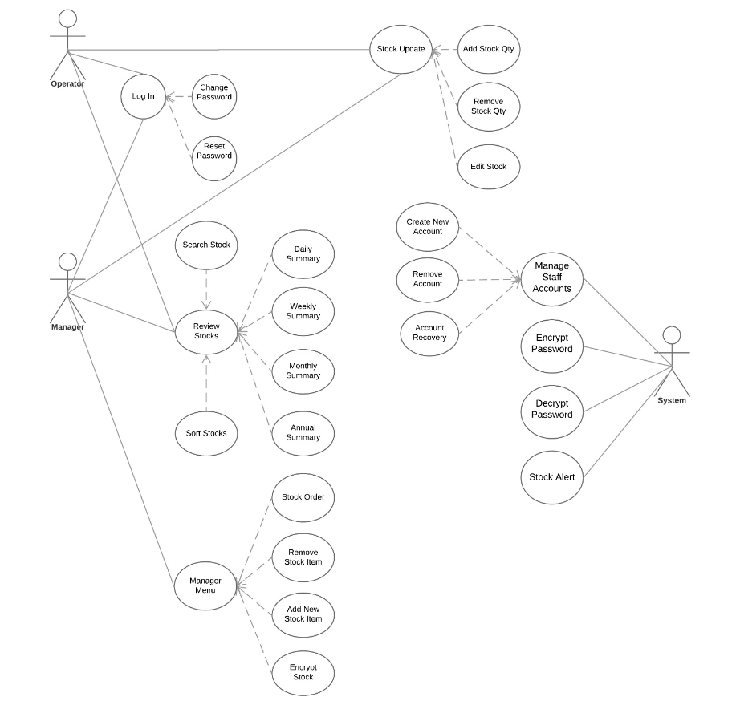

- Project Plan

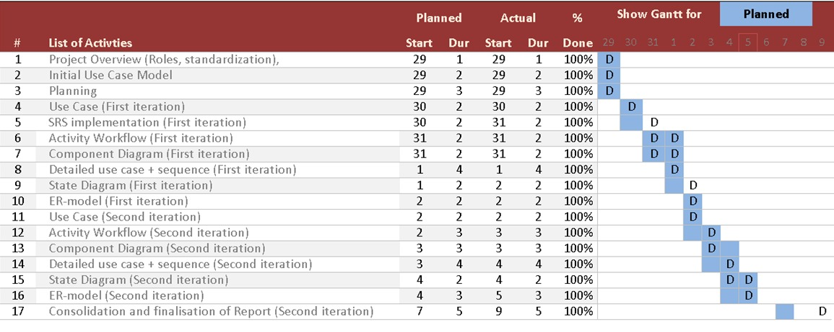

Roles and Responsibility

Team Number: G6

 | Student Name | Role | Artefacts
1 | Jia Yang | Manager | - Group meeting min  - Review perception of the current status of project  - Schedule agenda items  - Vetting of Work Diary by individual members on progress  - Identify of “urgent action items” and allocations  - Proposal for agenda items  - Gantt chart with IUP  - Group Report  - Risk Analysis & Mitigation (V2)
2 | Mark Lee | Lead Designer | - Component Diagram (I1 + I2)  - ER - Model (I1 + I2)  - Data Dictionary  - SRS (V2)
3 | Xu Ke | Designer | - Use Case Diagram (I1 + I2)  - Detail Use Case Scenario #1 (I1 + I2)  - Sequence Diagram #1 (I1 + I2)  - SRS (V2)
4 | Stanley | Lead Implementer | - Setup VCS + VCS evidence  - Detail Use Case Scenario #2 (I1 + I2)  - Sequence Diagram #2 (I1 + I2)
5 | How Wei | Documenter | - Project Overview (“Vision” Requirement Analysis & Constraints)  - Risk Analysis & Mitigation (V1)  - SRS (V1)
6 | Benjamin | Implementer | - Class Diagram (I1 + I2)  - Assisted with Group Report  - Risk Analysis & Mitigation (V2)  - Slides compilation
7 | Jun Yi | Tester | - Activity Diagram (I1 + I2)  - Data Dictionary (I1 + I2)  - Slides compilation

Risk Analysis and Counter Measures

 | Impact Type | Risk Seriousness (%) | Likelihood of Occurrence (%) | WBS  (affected work / task) | Risk Description
1 | Loss of data or corruption of work file | 80% | 15% |  | Software/Hardware failure resulting in data corruption or loss.
2 | Lack of Knowledge for implementing security measures/ incompetent teammates | 80% | 30% |  | Will not be able to develop a better security system for the different users
3 | Completing task successfully | 60% | 40% |  | Miscommunication among team members and misunderstand the question/requirements
4 | Lack of motivation / drive. Or procrastination | 50% | 60% | ALL | Delayed work and not able to follow planned timeline, which will bring team morale down

 | Risk Description | Proposed Mgmt Plan | (Possible) Reduction in Risk Seriousness (%)
1 | Software / Hardware failure resulting in data corruption or loss. | Plan 1: Constantly / Multiple backups | -70%
1 |  | Plan 2: Work on cloud platforms (Google Docs etc) | -60%
2 | Lack of Knowledge for implementing security measures/ incompetent teammates | Plan 1: Seek help from seniors/professor | -30%
2 |  | Plan 2: Forums/online tutorials | -60%
3 | Completing task successfully | Plan 1: consult with professor on areas with uncertainty | -80%
3 | Completing task successfully | Plan 2: Ensure smooth communication by progress with each other | -55%
4 | Lack of motivation / drive. Or procrastination | Plan 1: get to know each other better (maybe have a meal together)/offering to help others with their parts | -65%

Design Artefacts - Use Cases (Iteration 1)
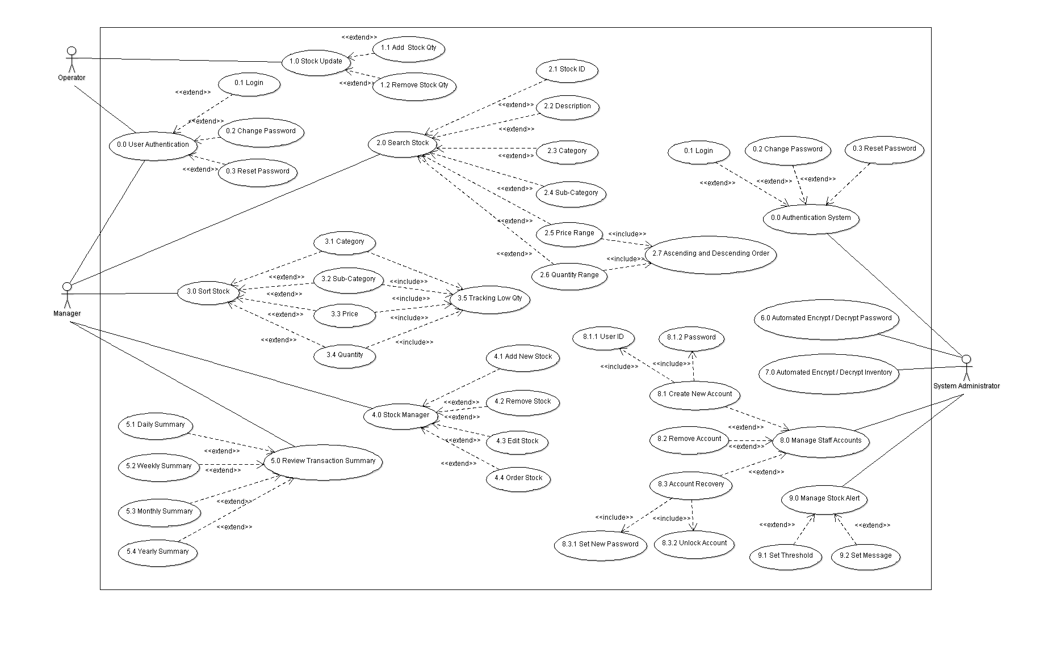
Design Artefacts - Use Cases (Iteration 2)

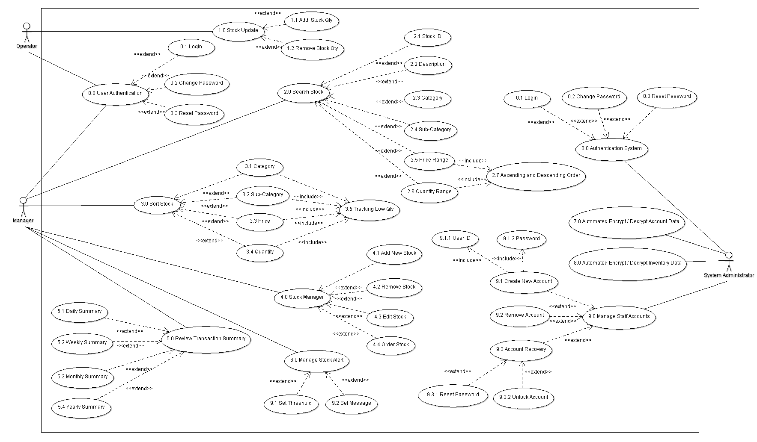
Design Artefacts - Use Cases (Iteration 3)

Design Artefacts - Activity Workflows (Iteration 1)
Warehouse Operator

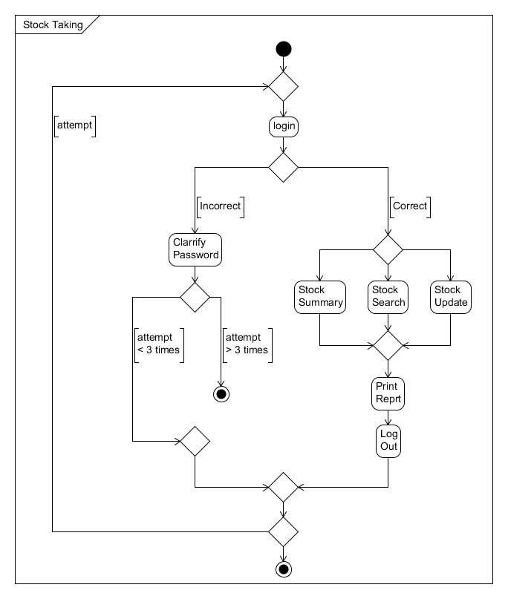

Design Artefacts - Activity Workflows (Iteration 1)
Manager
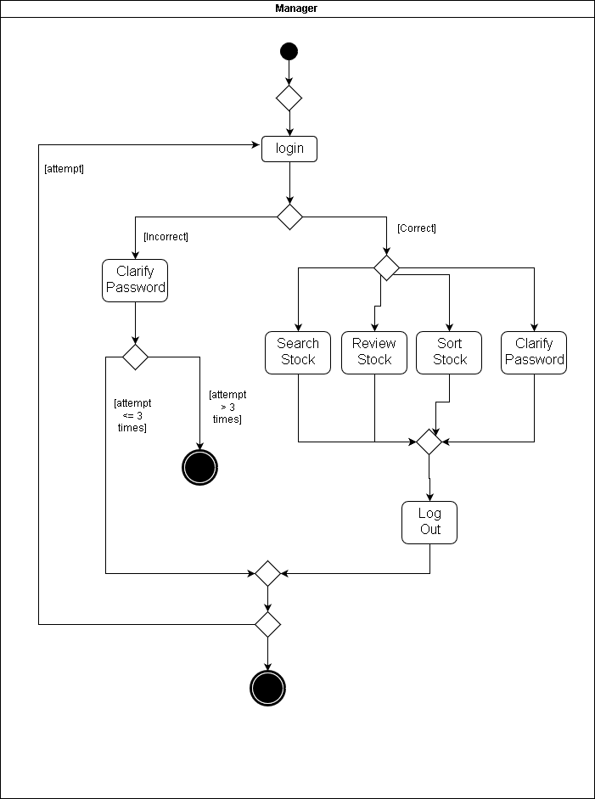

Design Artefacts - Activity Workflows (Iteration 1)
System Administrator

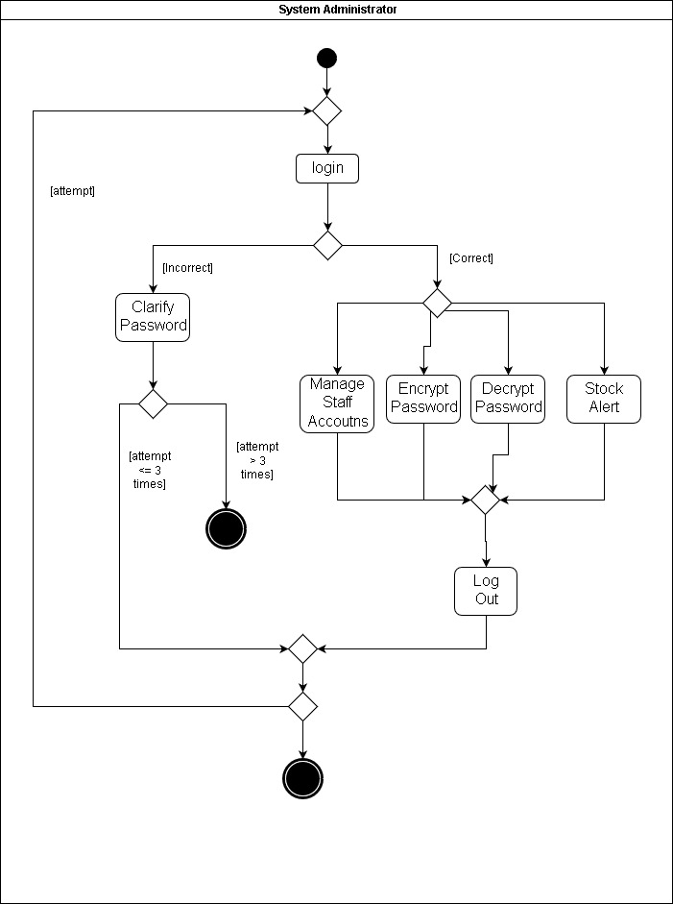
Design Artefacts - Activity Workflows (Iteration 2)
Warehouse Operator

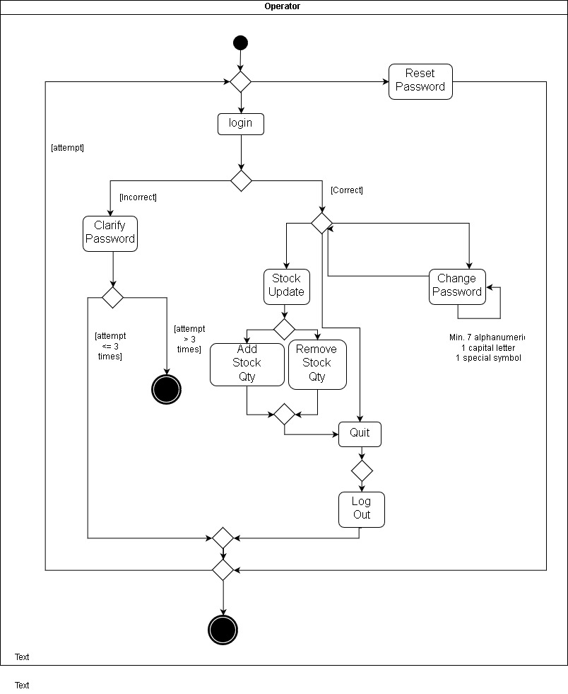
Design Artefacts - Activity Workflows (Iteration 2)
Manager

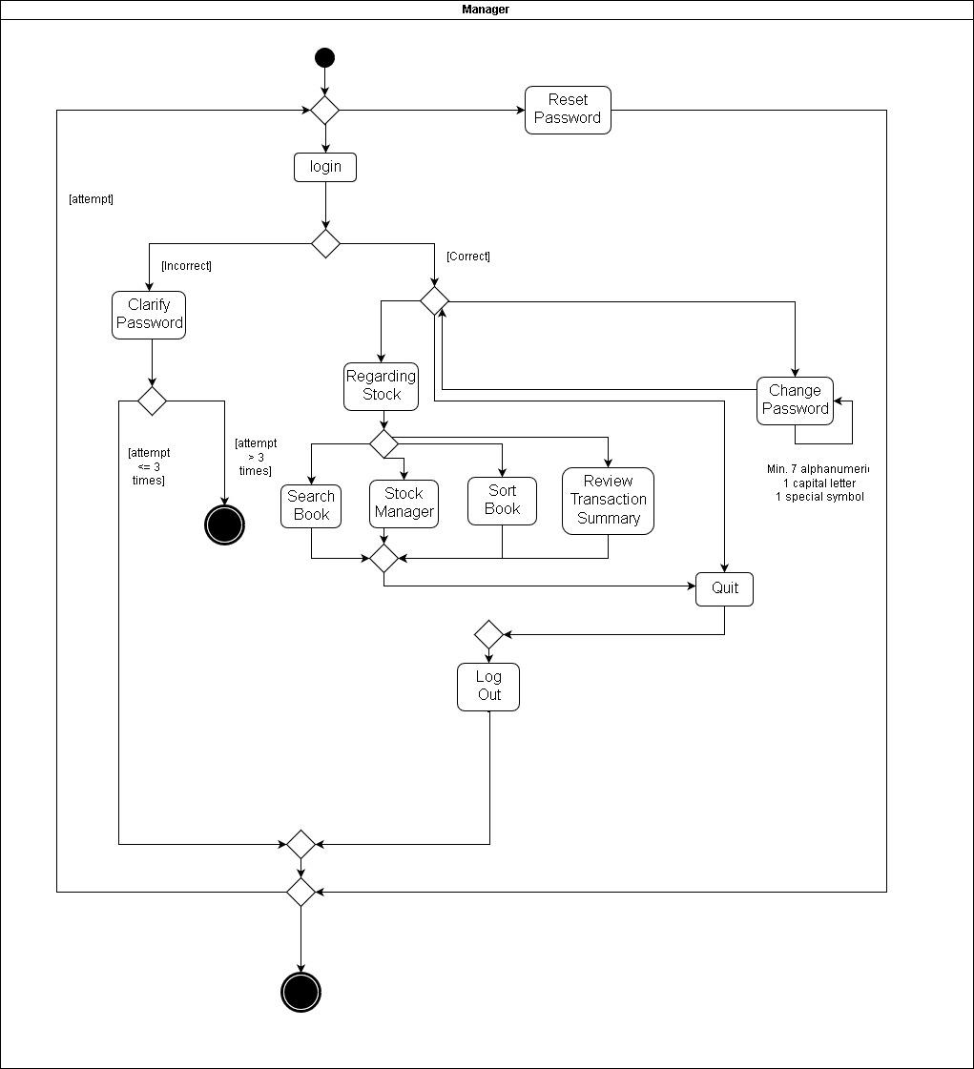
Design Artefacts - Activity Workflows (Iteration 2)
System Administrator
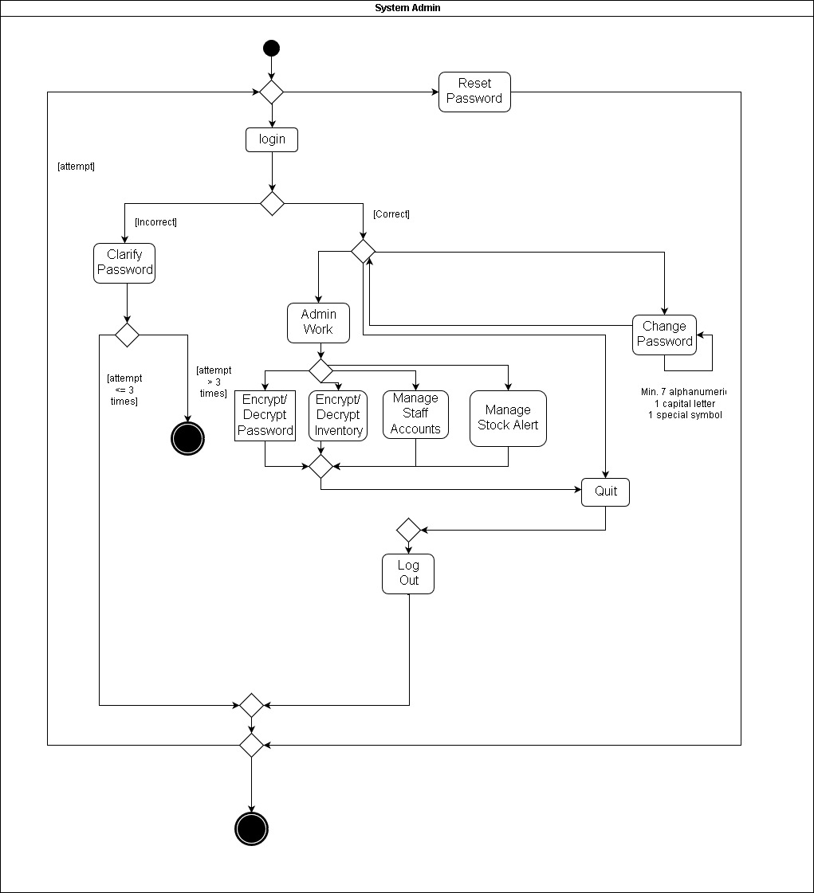
Design Artefacts - Activity Workflows (Iteration 3)
Warehouse Operator

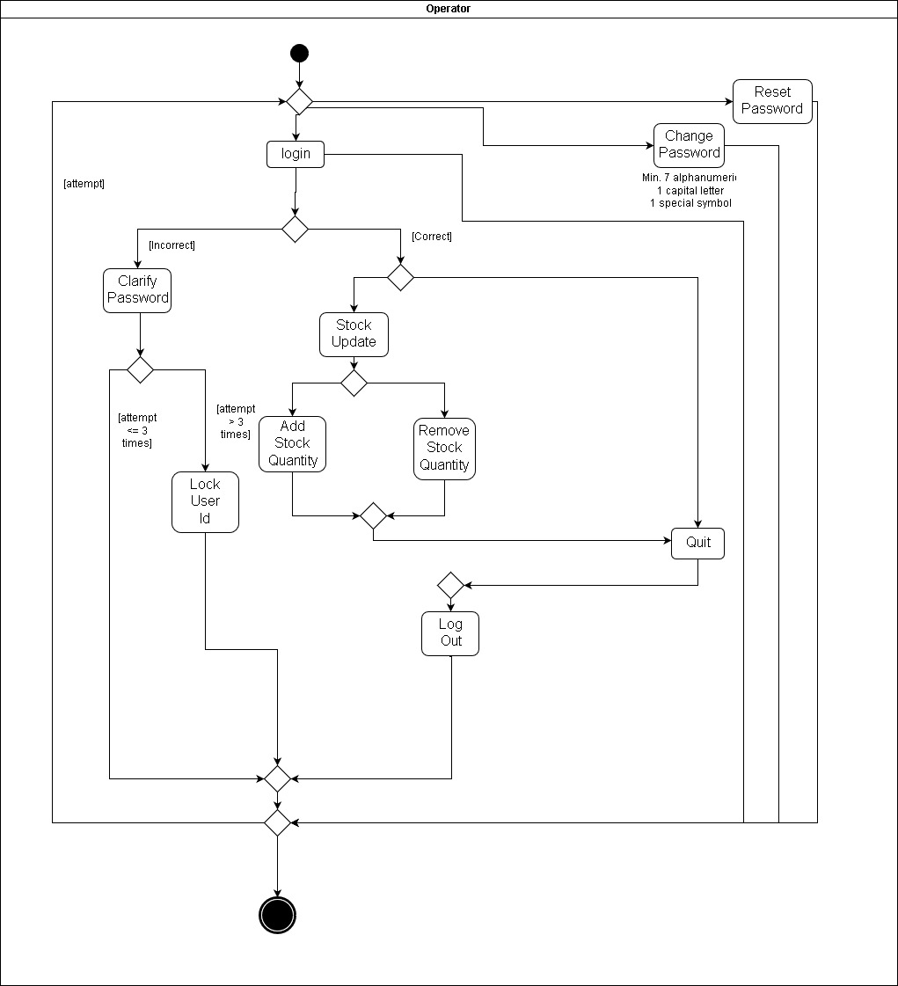
Design Artefacts - Activity Workflows (Iteration 3)
Manager

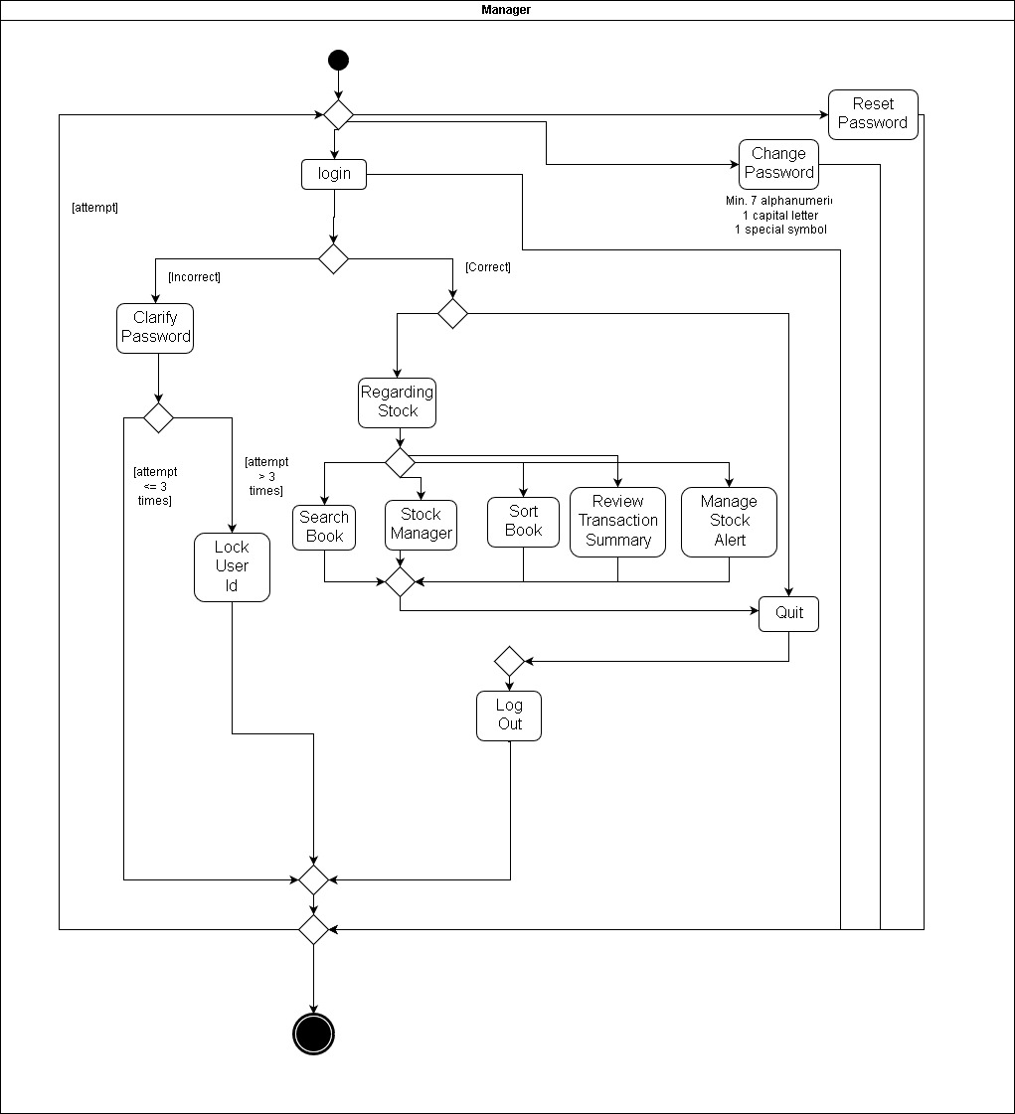
Design Artefacts - Activity Workflows (Iteration 3)
System Administrator

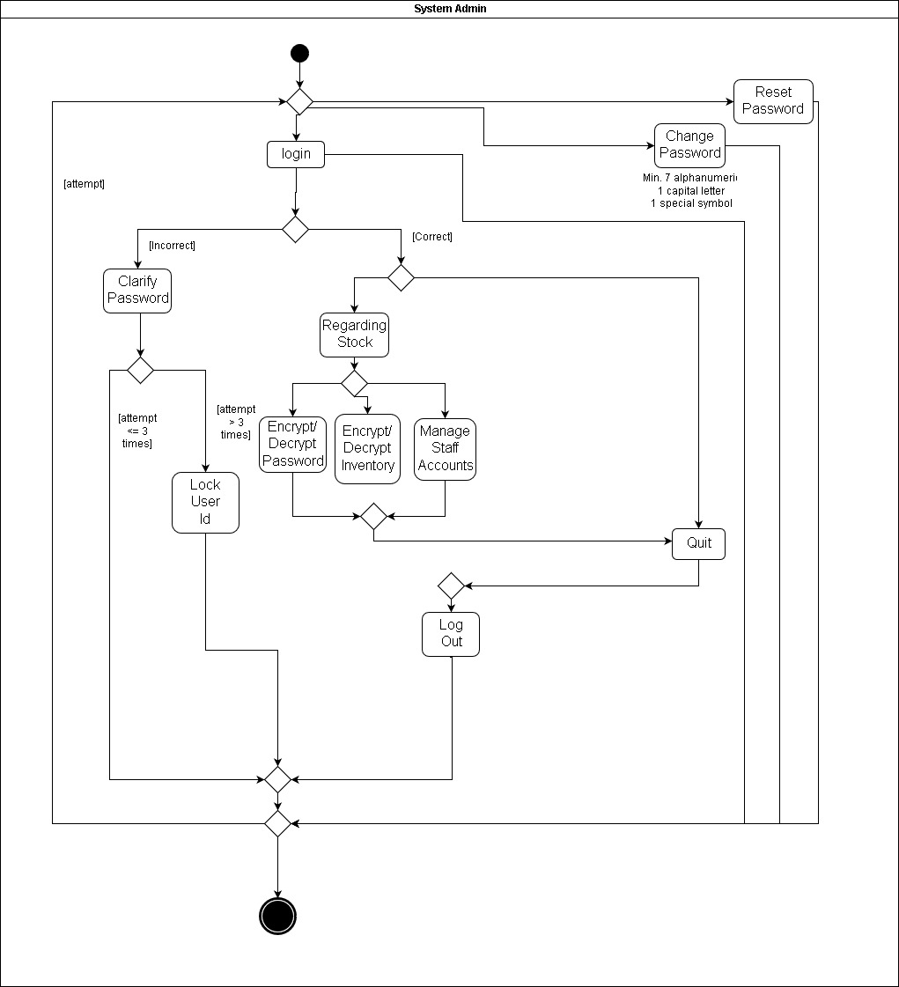
Design Artefacts - Component Diagrams (Iteration 1)

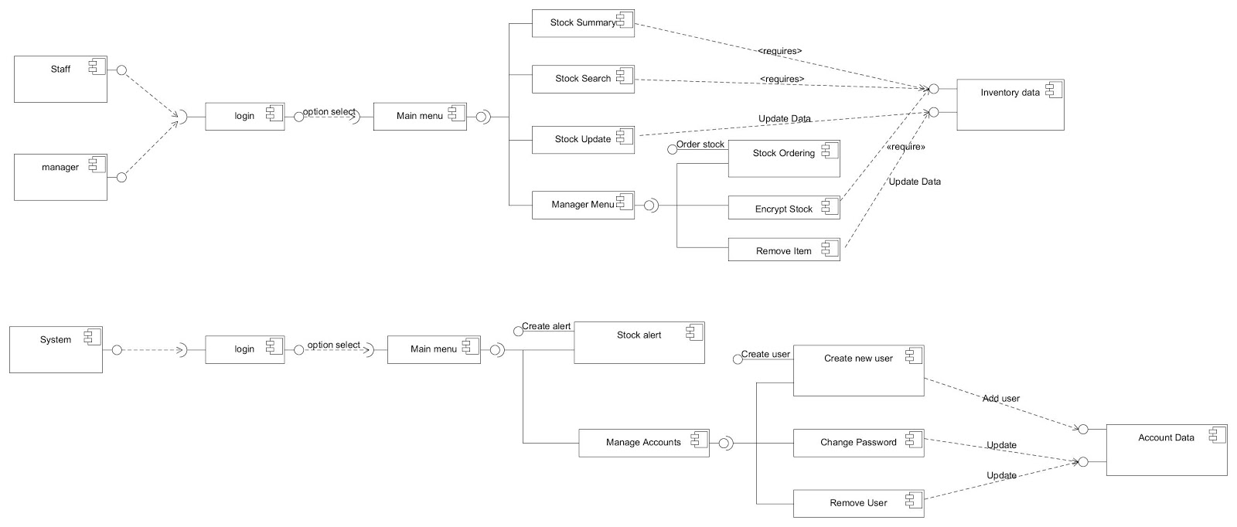

Design Artefacts - Component Diagrams (Iteration 2)
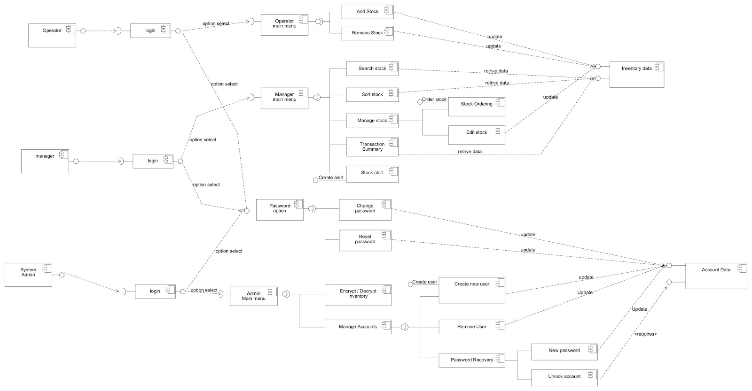

Design Artefacts - Component Diagrams (Iteration 3)

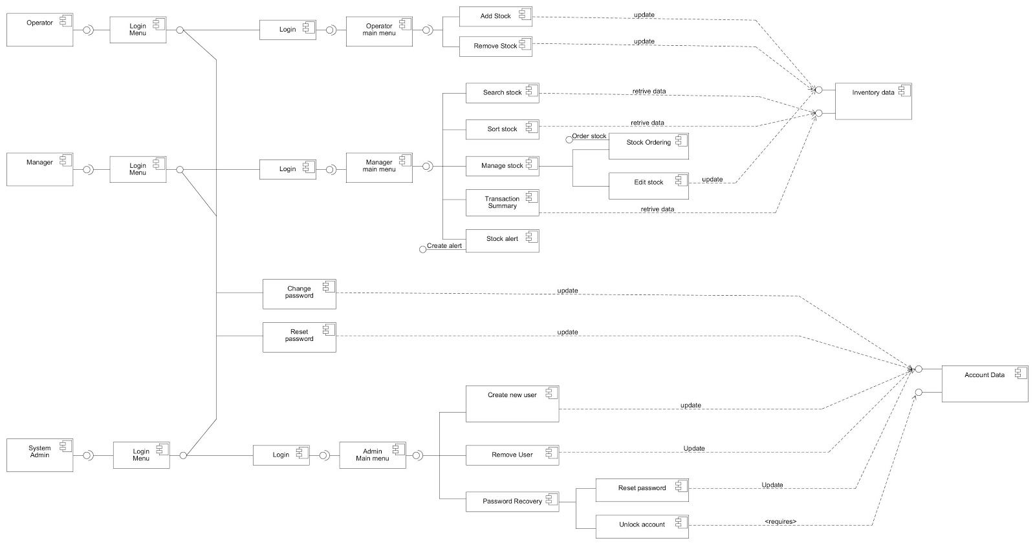
Design Artefacts - Class Diagrams (Iteration 1)

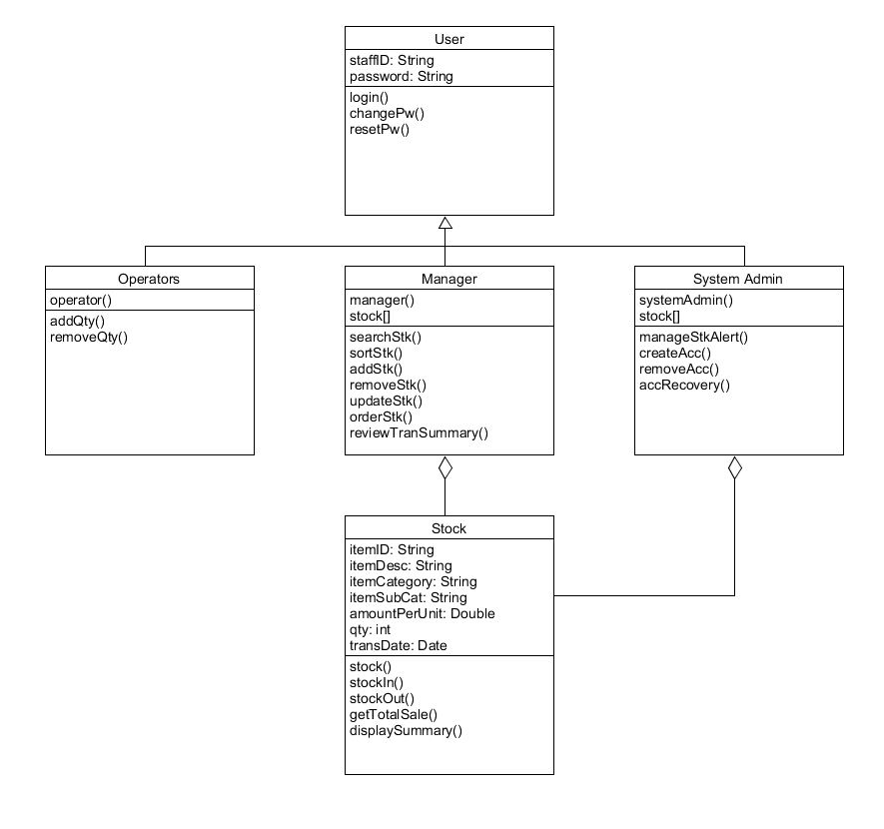

Design Artefacts - Class Diagrams (Iteration 2)

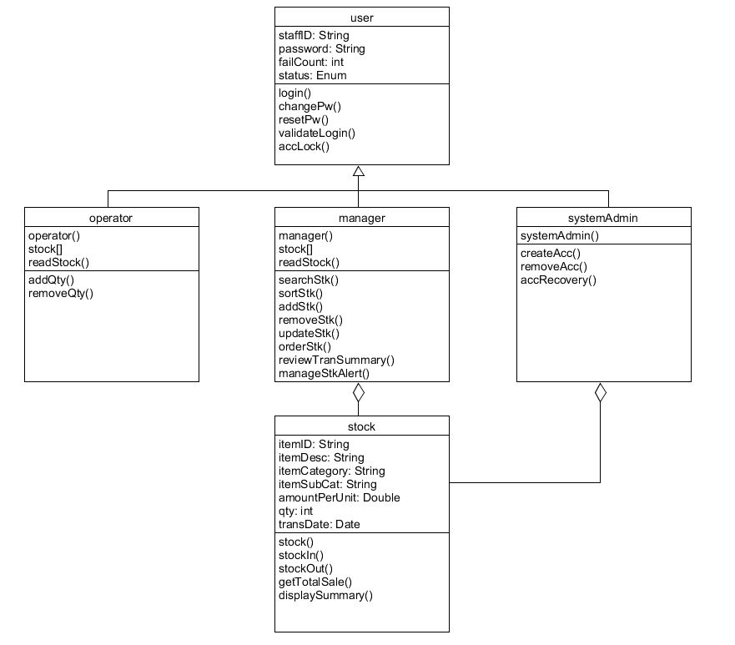

Design Artefacts - Class Diagrams (Iteration 3)
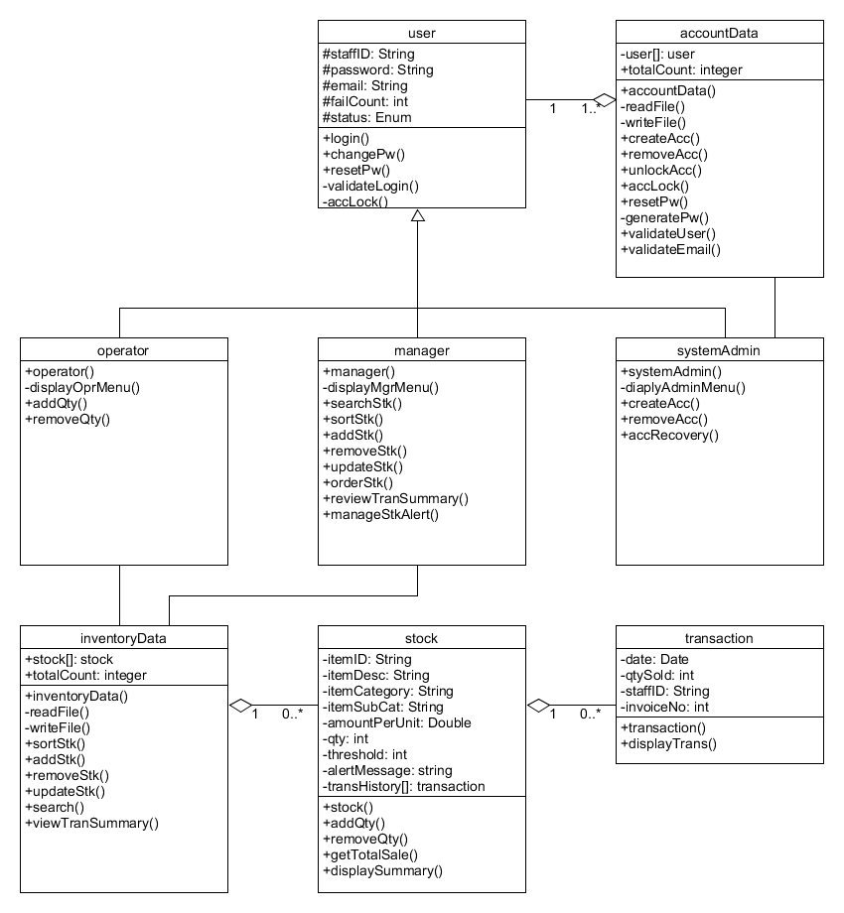

Design Artefacts – Detailed Use Case Scenario #1(I1)

Use Case Textual Description
UC-ID | 0.0
Name | User Authentication
Description | User authentication is identified to be key to the security of the system. Not only does it protects the system from unauthorized usage, it also differentiates the intended user from three different levels of system permission through a logging in process. Password change and reset are other options on this menu.
Actor(s) | Operator, Manager, Administrator
Main Scenario | 1) At user authentication screen, user enters his ID and password  2) Authentication success, user enters his permitted menu  3) User choose to quit, his account is logged out back to user authentication screen  4) User choose to change password, he is prompted to enter his ID, old password and new password  5) Authentication success, password is changed  6) User choose to reset password, he is prompted to enter his ID and staff email address  7) Authentication success, random new password is generated and sent to his staff email
Sub Scenario | 1) At user authentication screen, user enters his ID and password  2) Authentication failure, user will be prompted to enter his password again  3) After three fails, user’s account will be locked, he may not attempt anymore  4) Administrator will be notified of a locked account

Design Artefacts – Detailed Use Case Scenario #1(I2)

Use Case Textual Description
UC-ID | 0.0
Name | User Authentication
Description | User authentication is identified to be key to the security of the system. Not only does it protects the system from unauthorized usage, it also differentiates the intended user from three different levels of system permission through a logging in process. Password change and reset are other options on this menu.
Actor(s) | User, Operator, Manager, Administrator, Account Database
Main Scenario | 1) At user authentication screen, user enters his ID and password  2) Account database begins verification returning success  3) An instance of operator, manager, administrator will be created  4) User’s respective permitted menu will be displayed  5) User choose to quit, his account is logged out to user authentication screen  6) User choose to change password, he is prompted to enter his ID, current password and new password  7) Authentication success, password is changed  8) User choose to reset password, he is prompted to enter his ID and staff email address  9) Authentication success, random new password is generated and sent to his staff email
Sub Scenario | 1) At user authentication screen, user enters his ID and password  2) Account database begins verification returning failure, user may re-attempt  3) After three fails, user’s account will be locked, he may not attempt anymore

Design Artefacts – Sequence Diagram #1 (I1)
Login Success

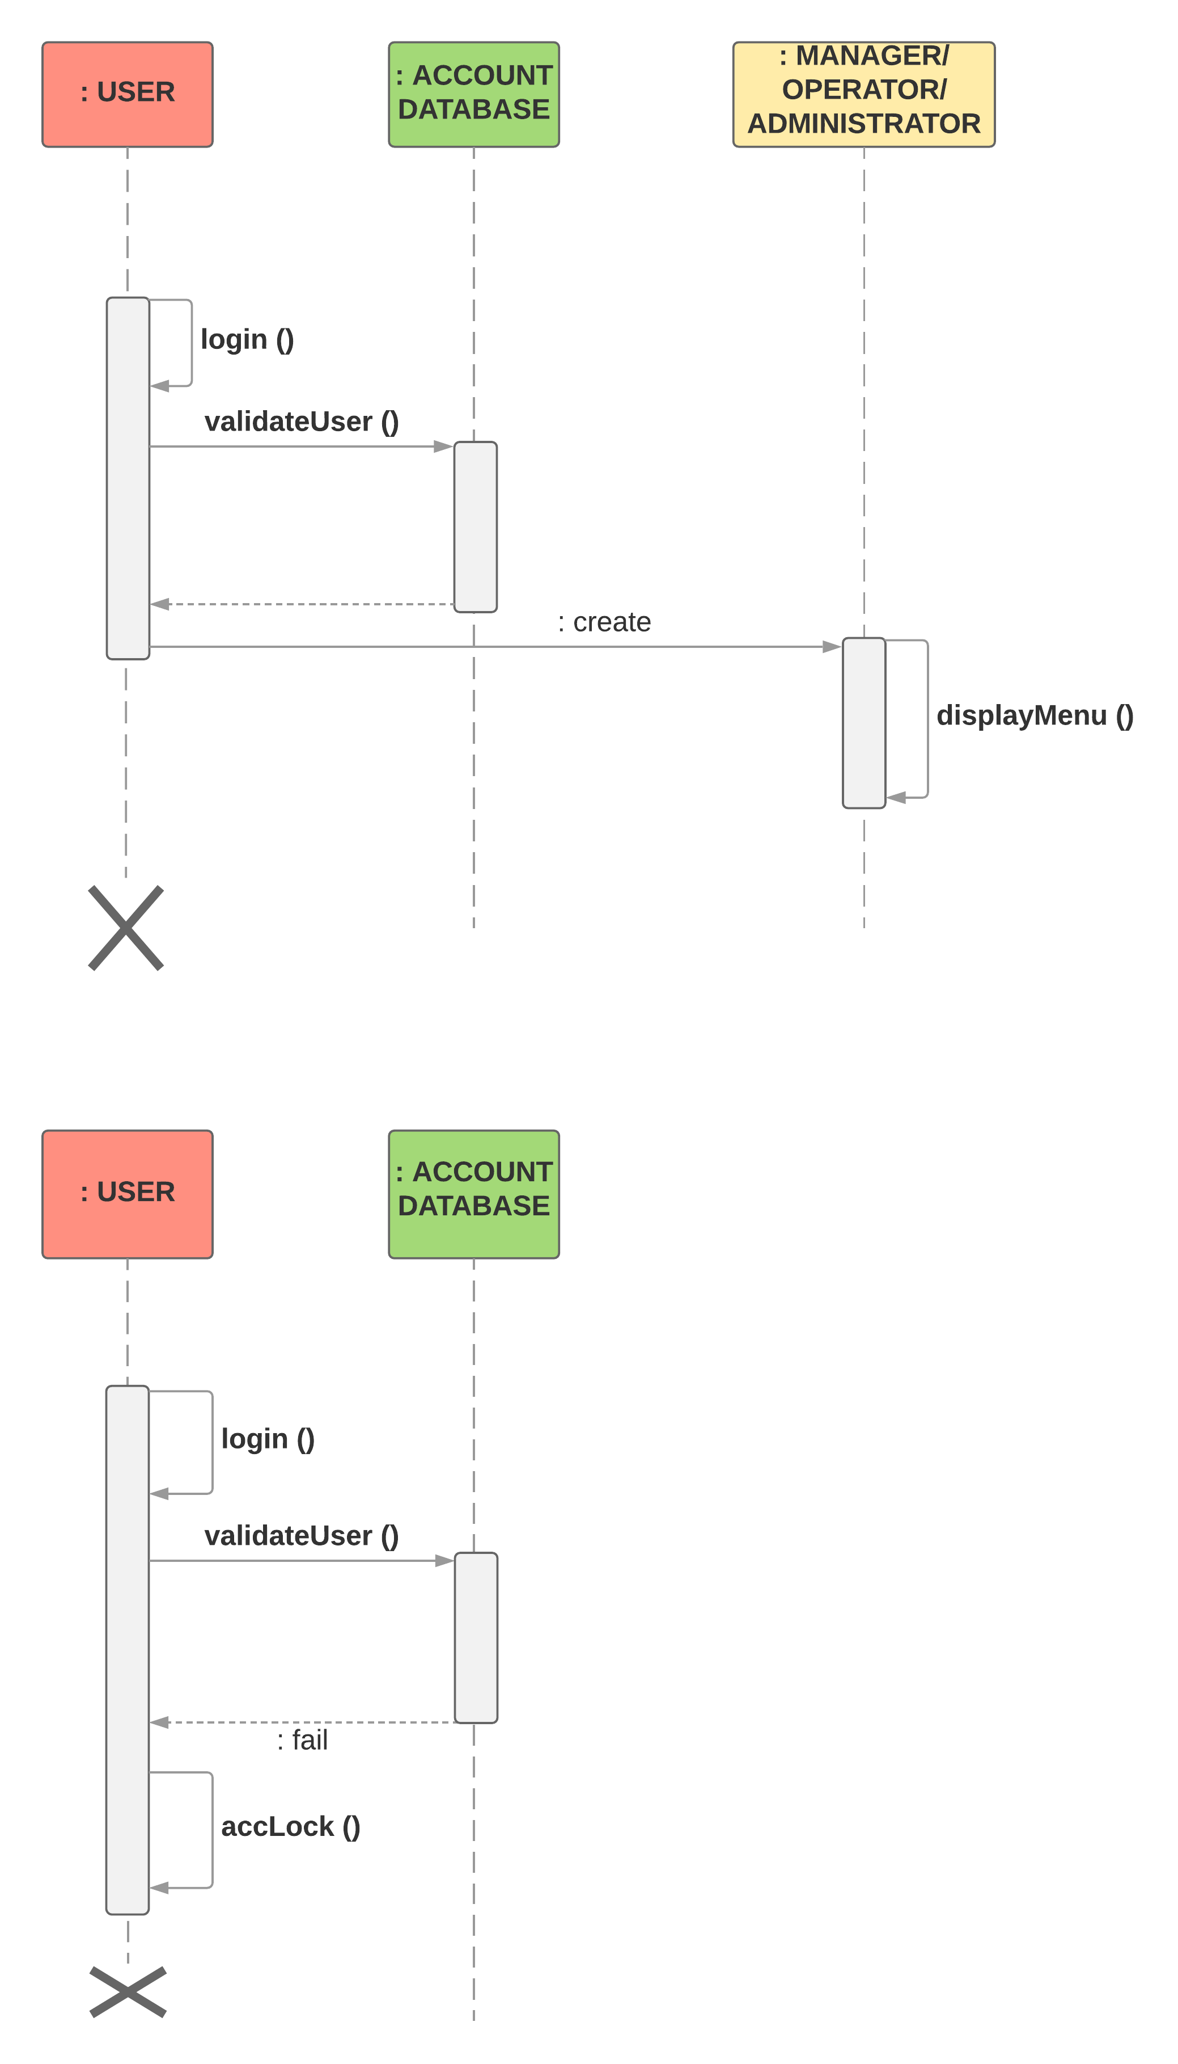

Design Artefacts – Sequence Diagram #1 (I1)
Change/Reset Password
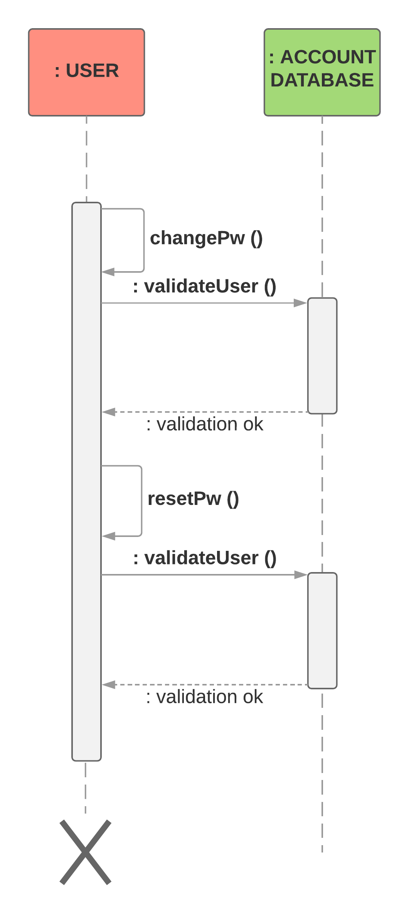

Design Artefacts – Sequence Diagram #1 (I1)
Sub Scenario - Login Failure X3

Design Artefacts – Sequence Diagram #1 (I2)
Login Success

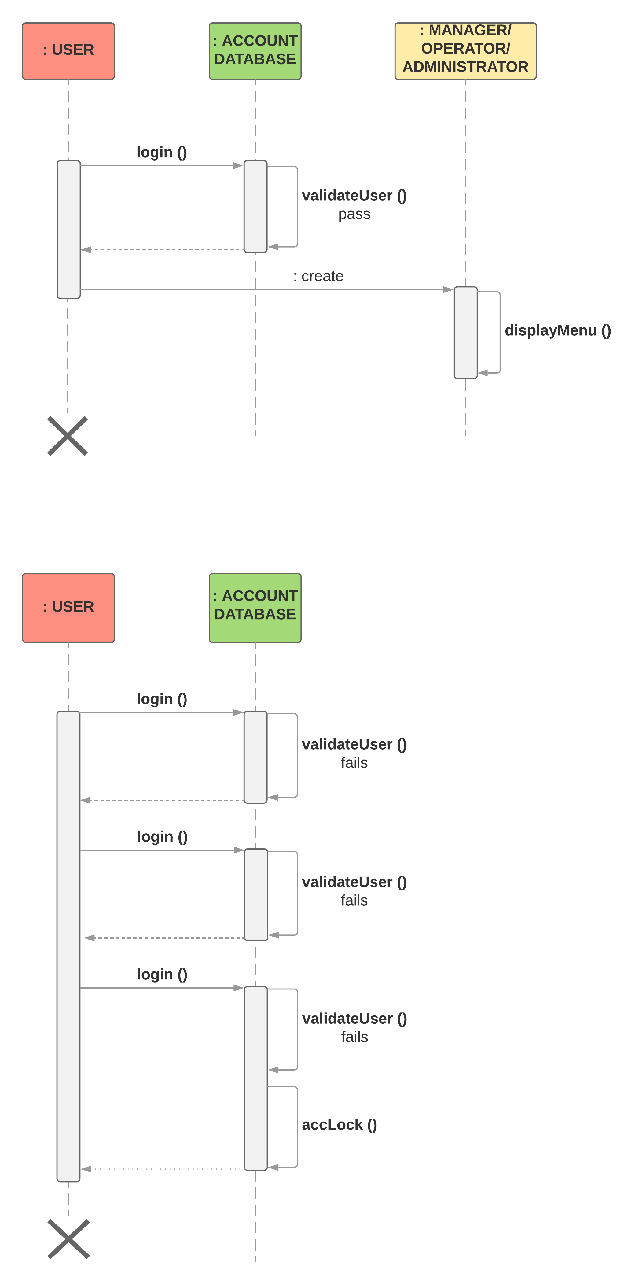

Design Artefacts – Sequence Diagram #1 (I2)
Change/Reset Password

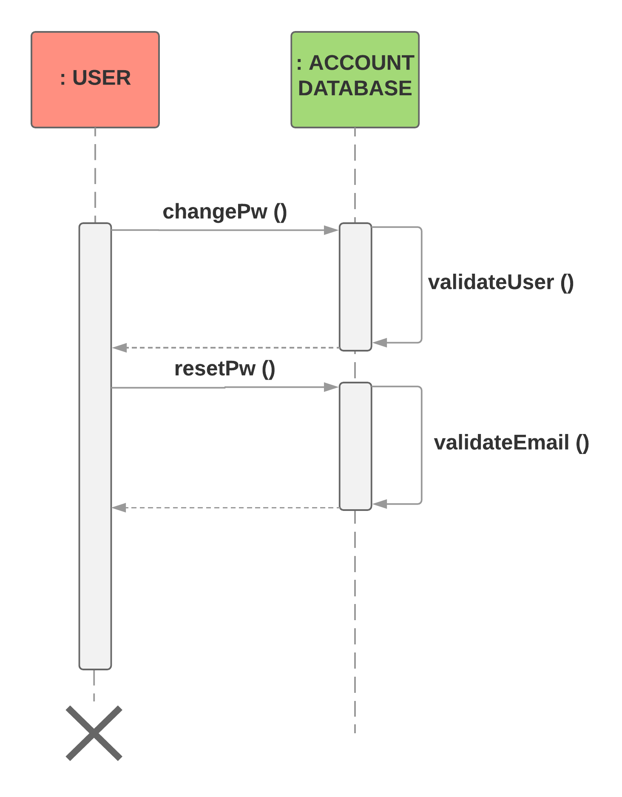

Design Artefacts – Sequence Diagram #1 (I2)
Sub Scenario - Login Failure X3

Design Artefacts – Sequence Diagram #1 (I3)
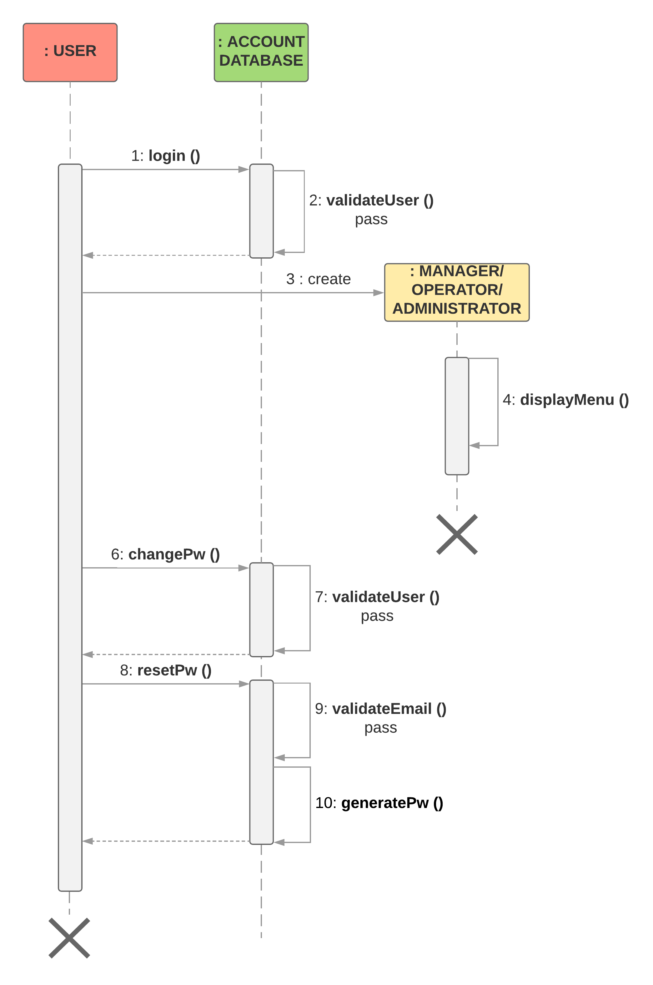
Login Success / Change Password / Reset Password

Design Artefacts – Sequence Diagram #1 (I3)
Sub Scenario - Login Failure X3
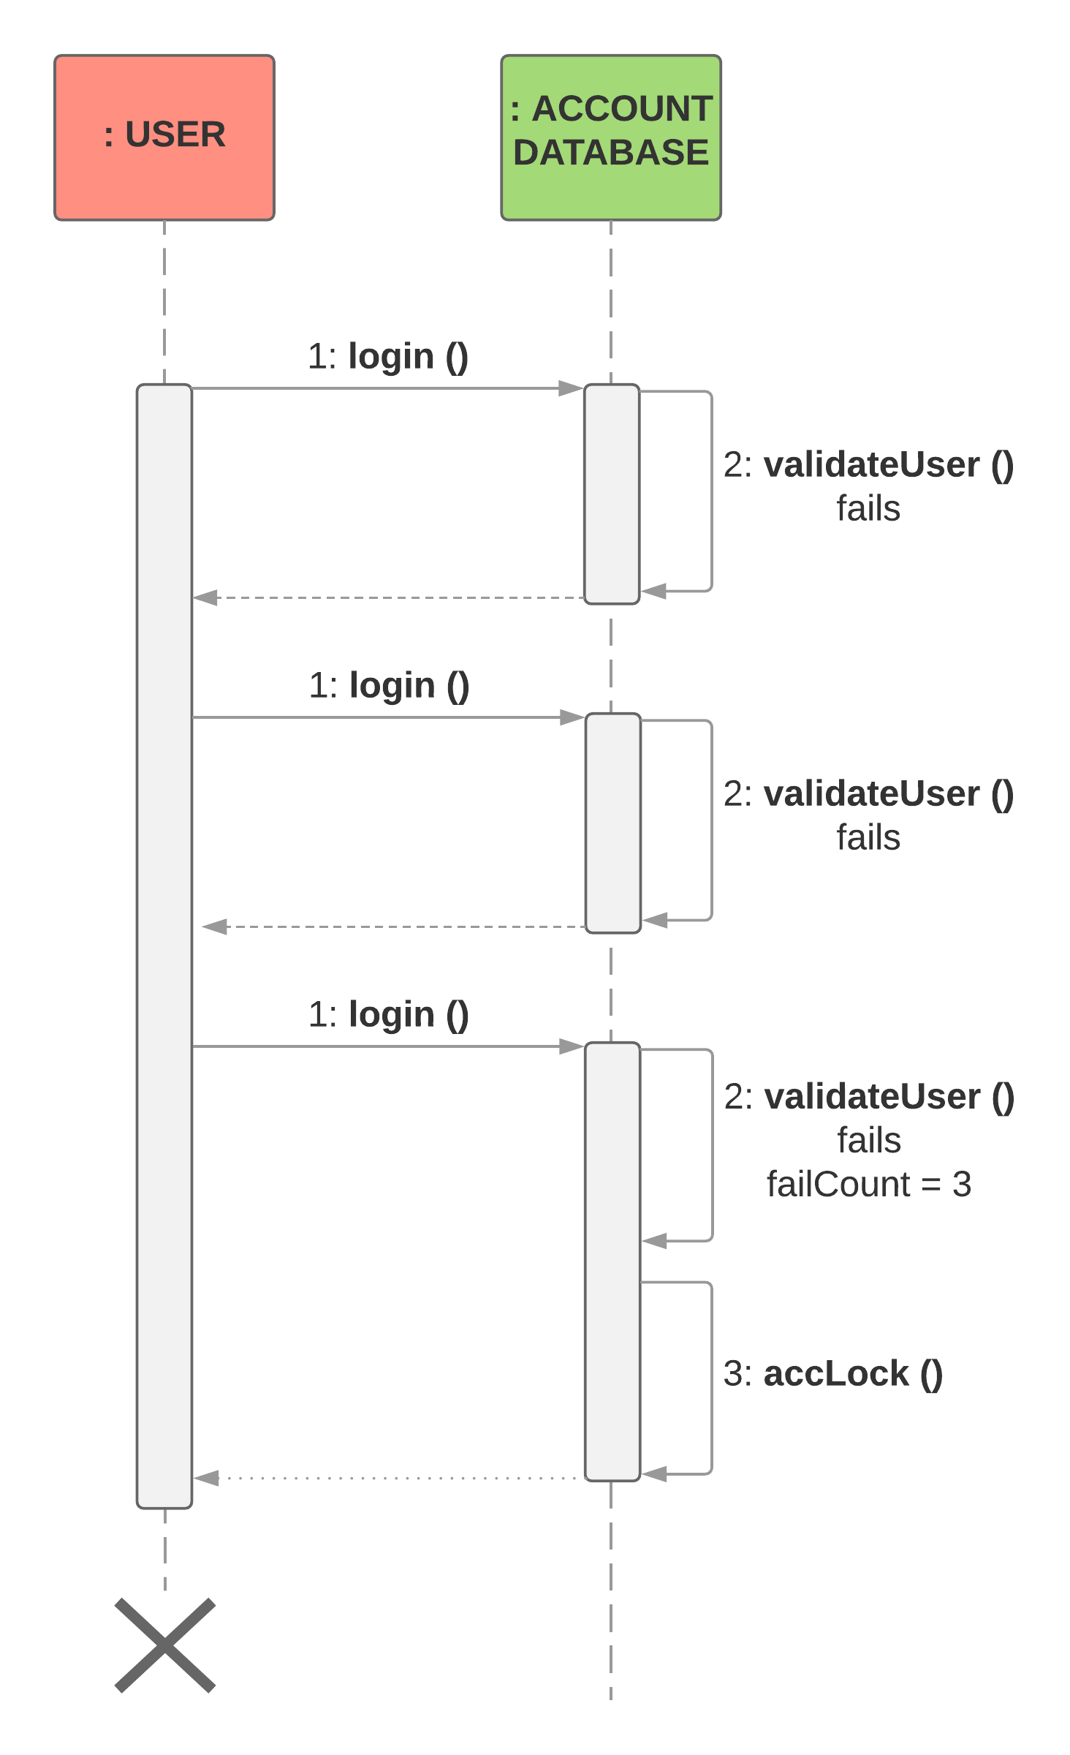
Design Artefacts – Detailed Use Case Scenario #2 (I1)

Use Case Textual Description
UC-ID | 5.0
Name | Review Transaction Summary
Description | System for reviewing transactions done during a chosen timeframe.
Actor(s) | Manager, Stock
Main Scenario | 1) Post successful login, Manager will see the main menu for managers  2) Manager chooses to update his stock array to ensure up to date.  3) Manager chooses review transaction summary and indicates timeframe of interest  4) The stock array is looped through and each stock has its purchase date compared  to the timeframe of interest  5) Only stocks with purchase dates within the timeframe are displayed.  6) After the loop subsides, a formatted transaction summary is displayed

Design Artefacts – Detailed Use Case Scenario #2 (I2)

Use Case Textual Description
UC-ID | 5.0
Name | Review Transaction Summary
Description | System for reviewing transactions done during a chosen timeframe.
Actor(s) | Manager, Inventory Database, Stock, Transaction
Main Scenario | 1) Post successful login, Manager will see the main menu for managers  2) Manager chooses review transaction summary and indicates timeframe of interest  3) Keeping track of the timeframe of interest, Inventory checks its stock array  4) Each stock is accessed, transaction array checked against the timeframe of interest  5) Each transaction, if date within the time frame is printed, otherwise, nothing is done.  6) After every internal loop subsides, a formatted transaction summary is displayed

Design Artefacts – Sequence Diagram #2 (I1)

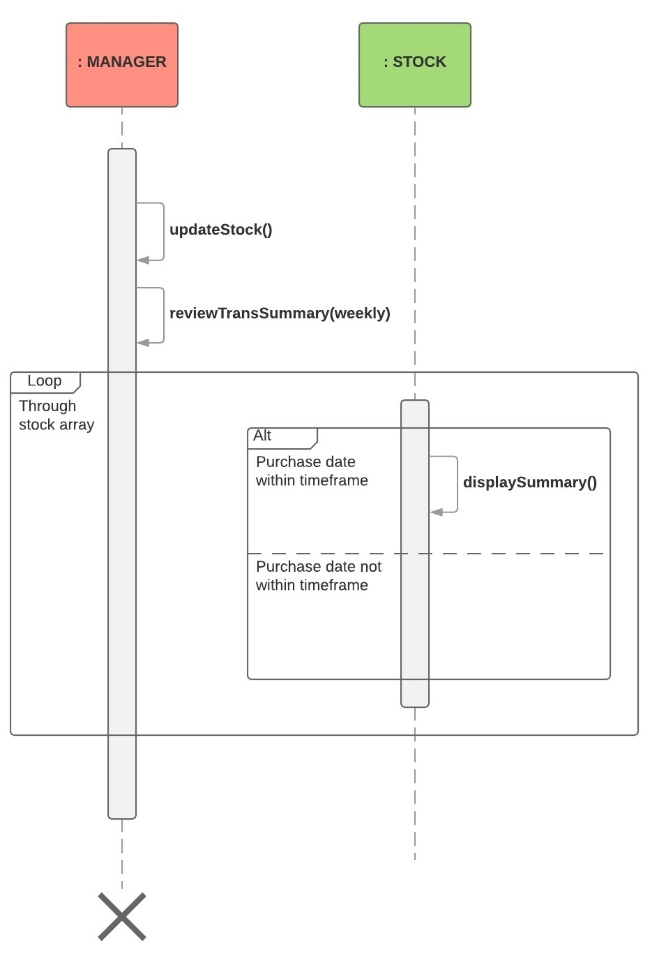
Design Artefacts – Sequence Diagram #2 (I2)
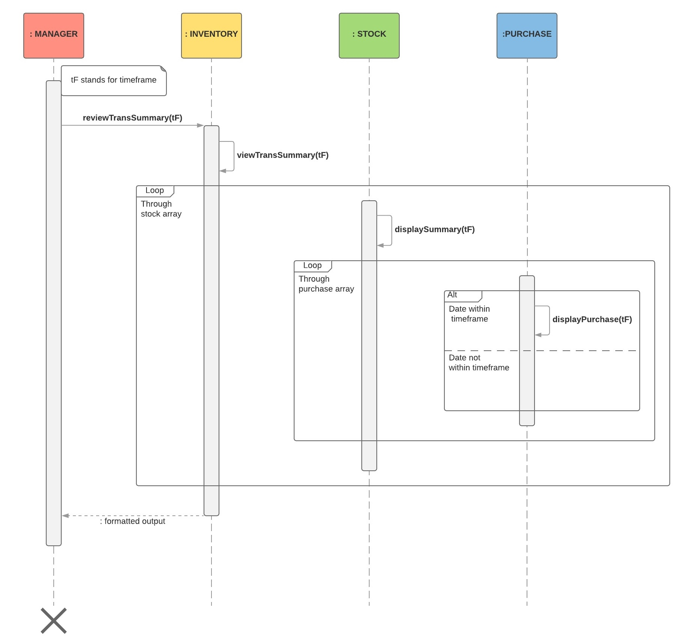

Design Artefacts – Sequence Diagram #3 (I2)
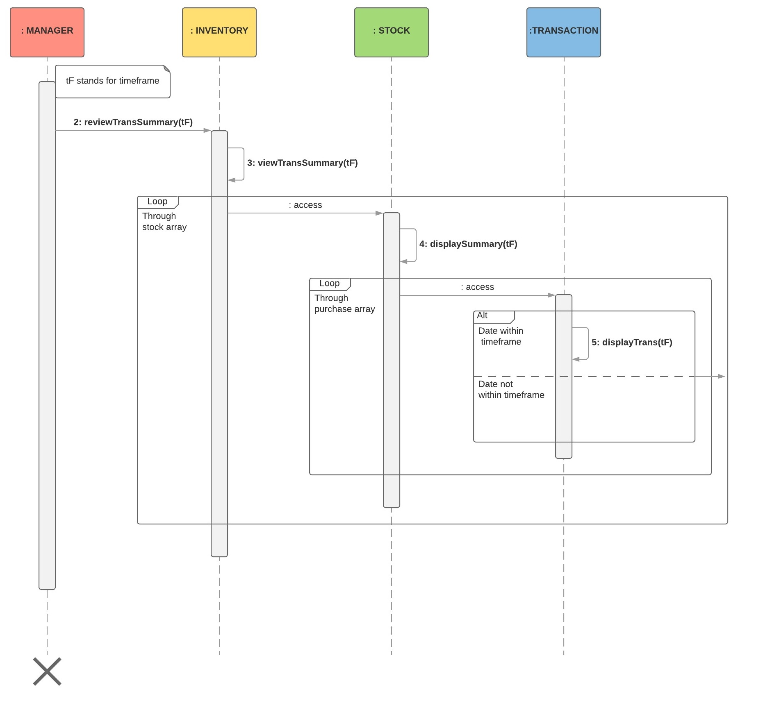

Design Artefacts – Data Dictionary (Iteration 1)

Class  (Name) | Attribute Name | Description | Type | Format | Range | Req’d | Related Class(es) | Nature of Relationship
User | staff_ID | Staff identification number | string | OXXXXXX  (Operators),  MXXXXXX  (Managers),  AXXXXXX  (Admins) |  | Y | Operators,  Manager,  System Admin | Inheritance Superclass => User
User | password | Account password | string | Minimum 7 alphanumeric,  1 capital letter,  1 special symbol |  | Y
Operators |  |  |  |  |  |  |  | Inheritance Superclass => User
Manager |  |  |  |  |  |  |  | Inheritance Superclass => User
System admin |  |  |  |  |  |  |  | Inheritance Superclass => User
Stock | item_ID | Item identification number | string |  |  | Y
Stock | item_Description | Describe the item | string |  |  | Y
Stock | item_Category | The different categories the item belongs to | string |  |  | Y
Stock | item_subCat | The item belongs to the sub categories | string |  |  | Y
Stock | amount_Per_Unit | The price of an individual item | double | Is in 2 decimals |  | Y
Stock | qty_Avail | The amount of the items in the inventory | integer |  |  | Y
Stock | qty_Sold | The amount of items sold
Stock | trans_Date | The date of transaction | DATE | DD/MM/YYYY |  | Y

Design Artefacts – Data Dictionary (Iteration 2)

Class  (Name) | Attribute Name | Description | Type | Format | Range | Req’d | Related Class(es) | Nature of Relationship
accountData | account_User | Information of the user | Array of user |  |  | Y | User | Instance of User class
User | staff_ID | Staff identification number | string | OXXXXXX  (Operators),  MXXXXXX  (Managers),  AXXXXXX  (Admins) |  | Y | Operators,  Manager,  System Admin | Inheritance Superclass => User
User | password | Account password | string | Minimum 7 alphanumeric,  1 capital letter,  1 special symbol |  | Y
User | fail_count | Count the number of times failing to login | integer |  |  | Y
User | status | Status of the account | enum |  | locked,  available | Y
Operators |  |  |  |  |  |  |  | Inheritance Superclass => User
Manager |  |  |  |  |  |  |  | Inheritance Superclass => User
System admin |  |  |  |  |  |  |  | Inheritance Superclass => User
Stock | item_ID | Item identification number | string |  |  | Y
Stock | item_Description | Describe the item | string |  |  | Y
Stock | item_Category | The different categories the item belongs to | string |  |  | Y
Stock | item_subCat | The item belongs to the sub categories | string |  |  | Y
Stock | amount_Per_Unit | The price of an individual item | double | Is in 2 decimals |  | Y
Stock | qty_Avail | The amount of the items in the inventory | integer |  |  | Y
Stock | threshold | The amount of items available must reach a certain an amount to be triggered | integer |  |  | Y
Stock | alert_MSG | Display a message when is necessary | string |  |  | Y
Stock | purchase_Histroy | Records of purchase made | Array of purchase |  |  | Y | Purchase | Instance of Purchase class
Purchase | date | Date of purchased | DATE | DD/MM/YYYY |  | Y
Purchase | qty_Sold | The amount of item being sold | integer |  |  | Y
Purchase | staff_ID | The staff that is handling the purchases | string | OXXXXXX  (Operators),  MXXXXXX  (Managers),  AXXXXXX  (Admins) |  | Y
Purchase | invoice_Num | The unique number that is systematically assigned to each invoice | integer | 9 -13 digit numbers |  | Y
inventoryData | inventory_Stock | Information of the stocks | Array of stock |  |  | Y | Stock | Instance of Stock class

Design Artefacts – Data Dictionary (Iteration 3)

Class  (Name) | Attribute Name | Description | Type | Format | Range | Req’d | Related Class(es) | Nature of Relationship
accountData | account_User | Information of the user | Array of user |  |  | Y | User | Instance of User class
User | staff_ID | Staff identification number | string | OXXXXXX  (Operators),  MXXXXXX  (Managers),  AXXXXXX  (Admins) |  | Y | Operators,  Manager,  System Admin | Inheritance Superclass => User
User | password | Account password | string | Minimum 7 alphanumeric,  1 capital letter,  1 special symbol |  | Y
User | fail_count | Count the number of times failing to login | integer |  |  | Y
User | status | Status of the account | enum |  | locked,  available | Y
Operators |  |  |  |  |  |  |  | Inheritance Superclass => User
Manager |  |  |  |  |  |  |  | Inheritance Superclass => User
System admin |  |  |  |  |  |  |  | Inheritance Superclass => User
Stock | item_ID | Item identification number | string |  |  | Y
Stock | item_Description | Describe the item | string |  |  | Y
Stock | item_Category | The different categories the item belongs to | string |  |  | Y
Stock | item_subCat | The item belongs to the sub categories | string |  |  | Y
Stock | amount_Per_Unit | The price of an individual item | double | Is in 2 decimals |  | Y
Stock | qty_Avail | The amount of the items in the inventory | integer |  |  | Y
Stock | threshold | The amount of items available must reach a certain an amount to be triggered | integer |  |  | Y
Stock | alert_MSG | Display a message when is necessary | string |  |  | Y
Stock | purchase_Histroy | Records of purchase made | Array of purchase |  |  | Y | Purchase | Instance of Purchase class
Purchase | date | Date of purchased | DATE | DD/MM/YYYY |  | Y
Purchase | qty_Sold | The amount of item being sold | integer |  |  | Y
Purchase | staff_ID | The staff that is handling the purchases | string | OXXXXXX  (Operators),  MXXXXXX  (Managers),  AXXXXXX  (Admins) |  | Y
Purchase | invoice_Num | The unique number that is systematically assigned to each invoice | integer | 9 -13 digit numbers |  | Y
inventoryData | inventory_Stock | Information of the stocks | Array of stock |  |  | Y | Stock | Instance of Stock class

Appendix A - Formal Meeting Records

Inception Phase - Iteration 1

29th Jan 2018, 1200hrs

Members present:
Ben
How Wei
Jia Yang
Jun Yi
Mark
Xu Ke

Members absent:
Stanley

Meeting Notes:
- Roles assigned (Leader: Jia Yang, Lead designer: Mark, Designer: Xu Ke, Lead Implementer: Stanley, Implementer: Ben, Tester: Jun Yi, Documenter: How Wei)
- Identified risks
- Standardized work diary format
- Functional & non-functional requirements
- Diagram – Operator, Manager, System
- Discussed Gantt chart
- Requirement analysis
- Risk analysis countermeasures

Action items (Person-in-charge):

- Next meeting (1st Feb, 1500hrs)
- Project Overview - How Wei
- Initial Use Case Model - Xu Ke
- Planning: Gantt Chart - Jia Yang
- Risk Analysis & Countermeasures - How Wei
- Activity Workflow - Jun Yi
- Component Diagram - Mark
- Research / Setup of Version Control Software - Stanley, Ben

Inception Phase - Iteration 2 (Optional)

1st Feb 2018, 1500hrs

Members present:
Ben
Jia Yang
Jun Yi
Xu Ke

Members absent:
Stanley
Mark
How Wei

Meeting Notes:
- Reviewed 1st iteration of use case model
- Reviewed Component Diagram of iteration 1
- Reviewed Activity Diagram of iteration 1
- Worked on class diagram
- Set up Version Control Software (VCS) via github.com

Action items (Person-in-charge):

- Next meeting (6th Feb, 1500hrs)
- To update Use Case diagram (system into a separate one) – Xu Ke
- To update Activity diagram – Jun Yi
- To finalize Class Diagram –Ben
- Detailed Use Case diagrams – Stanley, Xu ke
- Data dictionary – Jun Yi
- ER model - Mark

Elaboration Phase - Iteration 1
06th Feb 2018, 1000hrs

Members present:
Ben
How Wei
Jia Yang
Jun Yi
Mark
Xu Ke
Stanley

Meeting Notes:
- Reviewed Use Case (E + i2)
- Finished up component diagram (E + i2)
- Reviewed SRS Diagram (E2)
- Discussed on Activity Class diagram (i2)
- Finished up Data Dictionary (i2)
- Gantt Chart (i2)
- Vision, Risk, SRS (i2)

Action items (Person-in-charge):
- Next meeting (6th Feb, 1500hrs)
- SRS diagram to finalize – How Wei
- Activity Diagram (i3) – Jun Yi

Elaboration Phase - Iteration 2
06th Feb 2018, 1500hrs

Members present:
Ben
How Wei
Jia Yang
Jun Yi
Mark
Xu Ke
Stanley

Meeting Notes:
- Discussed and made changes to Activity Diagram
- Class Diagram (E + i2) done
- Activity Diagram (E + i2) done
- Finalized SRS diagram

Action items (Person-in-charge):
- Next meeting (9th Feb, 1100hrs)
- Vision and Risk to finalize – How Wei
- Report to complete – Jia Yang
- Update Gantt Chart - Jia Yang

Elaboration Phase - Iteration 3 (Optional)

- Copy and Paste your formal meeting minutes for Elaboration Phase, iteration 3 here.
- You can refer to Assn 1 Qn Paper, Appendix B, bullet point 4 for a summary of contents to be included.
- Note: this section can span as many pages as necessary

Appendix B - Individual Work Diaries

Team Member 1 : John Anderson

Inception Phase - Iteration 1

- Copy and Paste the relevant work diary for Inception Phase, iteration 1 here.
- You can refer to Assn 1 Qn Paper, Appendix B, bullet point 5 for a summary of contents to be included.
- Note: this section can span as many pages as necessary

Inception Phase - Iteration 2 (Optional)

- Copy and Paste the relevant work diary for Inception Phase, iteration 2 here.
- You can refer to Assn 1 Qn Paper, Appendix B, bullet point 5 for a summary of contents to be included.
- Note: this section can span as many pages as necessary

Elaboration Phase - Iteration 1

- Copy and Paste the relevant work diary for Elaboration Phase, iteration 1 here.
- You can refer to Assn 1 Qn Paper, Appendix B, bullet point 5 for a summary of contents to be included.
- Note: this section can span as many pages as necessary

Elaboration Phase - Iteration 2

- Copy and Paste the relevant work diary for Elaboration Phase, iteration 2 here.
- You can refer to Assn 1 Qn Paper, Appendix B, bullet point 5 for a summary of contents to be included.
- Note: this section can span as many pages as necessary

Elaboration Phase - Iteration 3 (Optional)

- Copy and Paste the relevant work diary for Elaboration Phase, iteration 3 here.
- You can refer to Assn 1 Qn Paper, Appendix B, bullet point 5 for a summary of contents to be included.
- Note: this section can span as many pages as necessary

Team Member 'N' : Xxxx Xxxx

Inception Phase - Iteration 1

- Copy and Paste the relevant work diary for Inception Phase, iteration 1 here.
- You can refer to Assn 1 Qn Paper, Appendix B, bullet point 5 for a summary of contents to be included.
- Note: this section can span as many pages as necessary

Inception Phase - Iteration 2 (Optional)

- Copy and Paste the relevant work diary for Inception Phase, iteration 2 here.
- You can refer to Assn 1 Qn Paper, Appendix B, bullet point 5 for a summary of contents to be included.
- Note: this section can span as many pages as necessary

Elaboration Phase - Iteration 1

- Copy and Paste the relevant work diary for Elaboration Phase, iteration 1 here.
- You can refer to Assn 1 Qn Paper, Appendix B, bullet point 5 for a summary of contents to be included.
- Note: this section can span as many pages as necessary

Elaboration Phase - Iteration 2

- Copy and Paste the relevant work diary for Elaboration Phase, iteration 2 here.
- You can refer to Assn 1 Qn Paper, Appendix B, bullet point 5 for a summary of contents to be included.
- Note: this section can span as many pages as necessary

Elaboration Phase - Iteration 3 (Optional)

- Copy and Paste the relevant work diary for Elaboration Phase, iteration 3 here.
- You can refer to Assn 1 Qn Paper, Appendix B, bullet point 5 for a summary of contents to be included.
- Note: this section can span as many pages as necessary

Appendix C - Evidence of using VCS (Version Control Software)

Version Control Software used : (E.g. Netbeans subversion, TortiseSVN, etc)

Note 1 : The following screenshots can span as many pages as necessary

Note 2 : Please ensure that all the wordings / text in your screen shots are clearly visible

Screenshot #1 - Contents in the VCS's Root Folder containing all Repository Project Files

< Paste Screenshot #1 image here >

Screenshot #2 - VCS's listing of all the latest source files currently being managed

< Paste Screenshot #2 image here >

Screenshot #3 - Example using VCS's to check-out source files (it may be necessary to do >1 screen capture, depending on the software used)

< Paste Screenshot #3 image(s) here >

Screenshot #4 - Example using VCS's to check-in source files (it may be necessary to do >1 screen capture, depending on the software used)

< Paste Screenshot #4 image(s) here >

Screenshot #5 - Example using VCS's to display the change history / log (it may be necessary to do >1 screen capture, depending on the software used)

< Paste Screenshot #5 image(s) here >

